Creating a Public bucket in S3
This process explains how to create a bucket in Amazon S3 and configure its settings to allow public access. It includes steps like creating the bucket, uploading files, and adjusting permissions so that the content can be accessed by anyone using a link.
- Dashboard
Go to the AWS Management Console and log in with your AWS account. After signing in, you will see the dashboard where all AWS services are accessible.

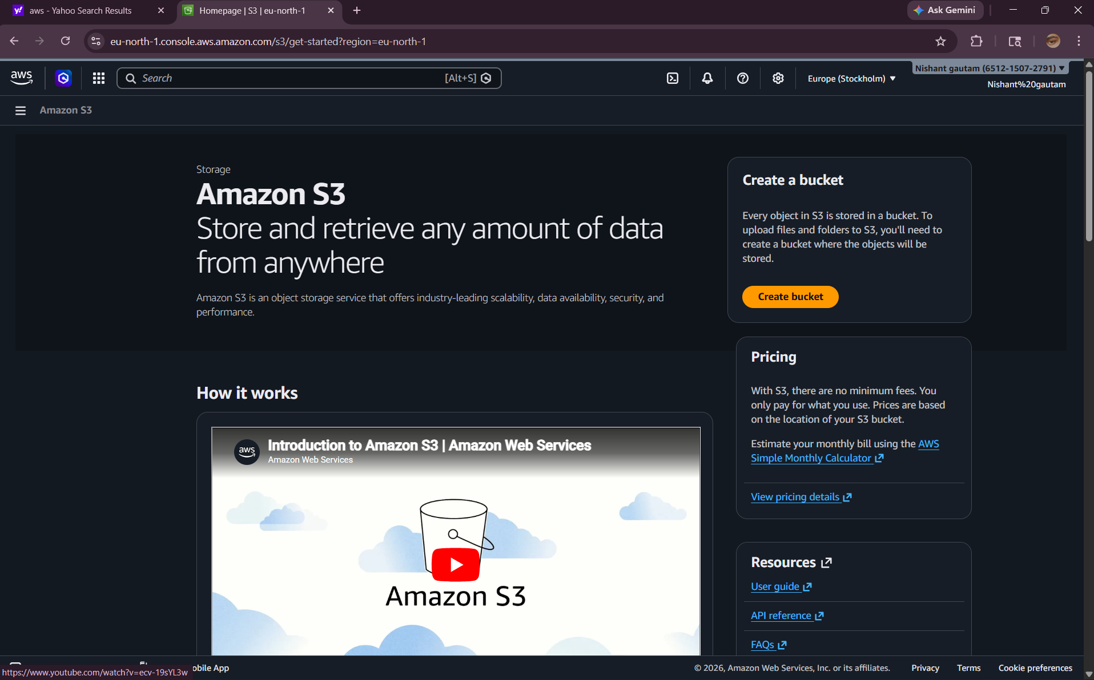

- Creating a Bucket
PS that, ACL stands for Access Control List. In the Amazon S3 section of the AWS Management Console, click on “Create bucket.” Enter a unique bucket name, select a region, and update the settings as shown in the screenshots. Then click “Create bucket” to finish.
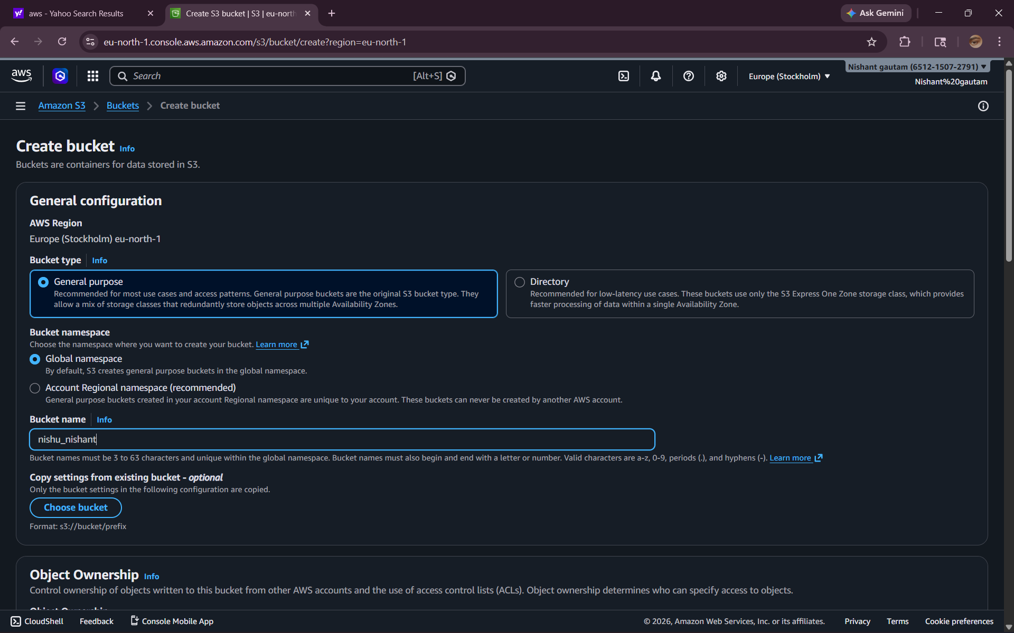
Then click “Create bucket” to finish.
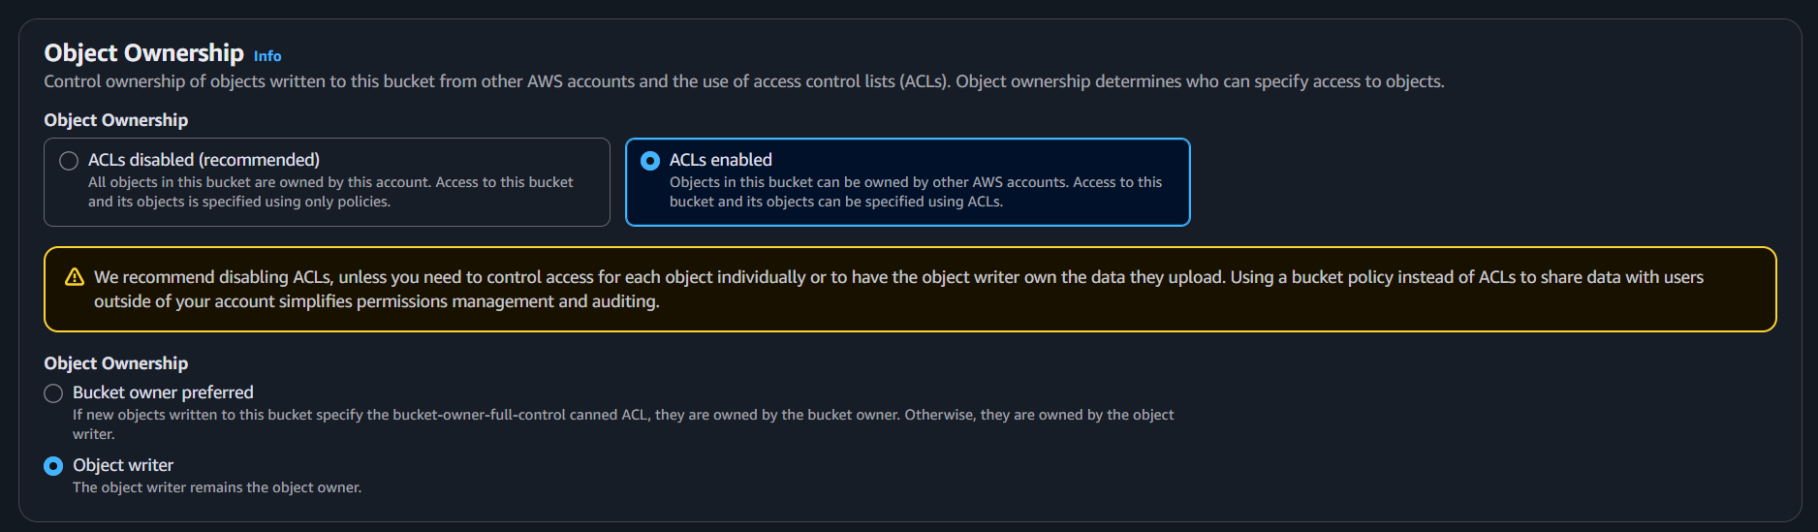The Bucket’s Dashboard
After creating the bucket, open the bucket named haadicoco in Amazon S3. You will be directed to its dashboard, where you can view and manage files, permissions, and settings of the bucket.
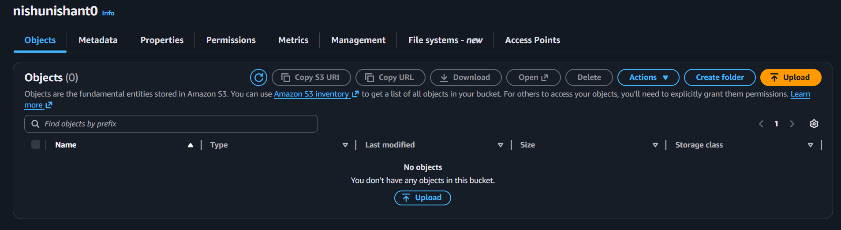
Uploading a file
Inside the haadicoco bucket in Amazon S3, click on “Upload.” Select the file from your system and click “Upload” to add it to the bucket.
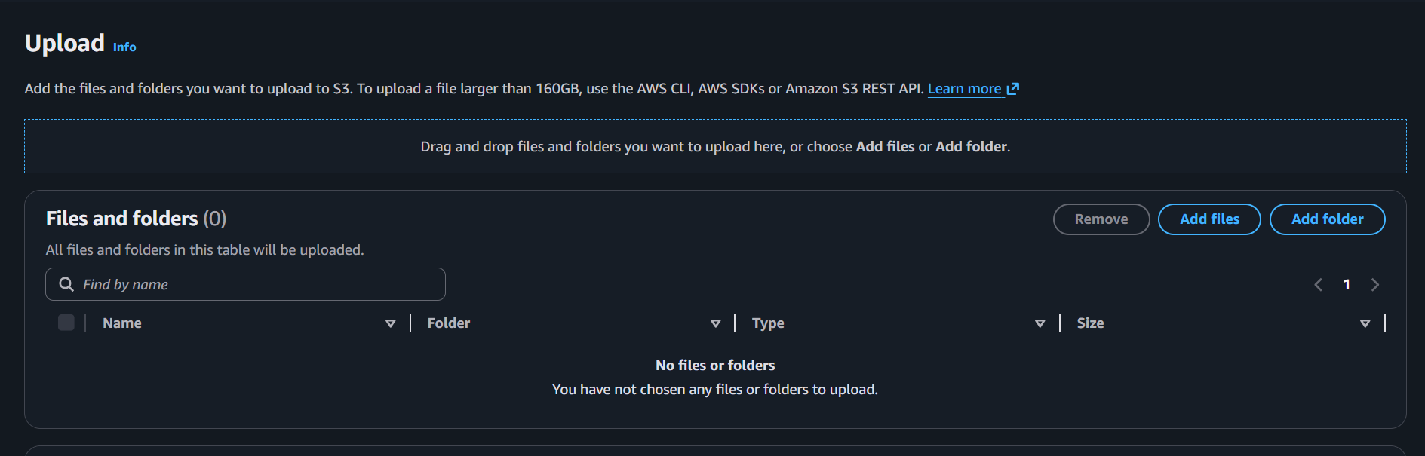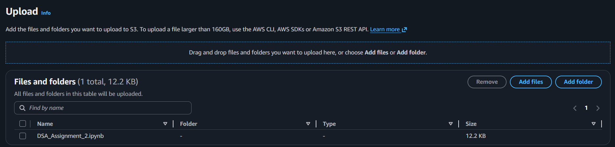
The File has successfully been uploaded
After the upload is complete, the file will appear in the haadicoco bucket in Amazon S3, confirming that it has been successfully uploaded.
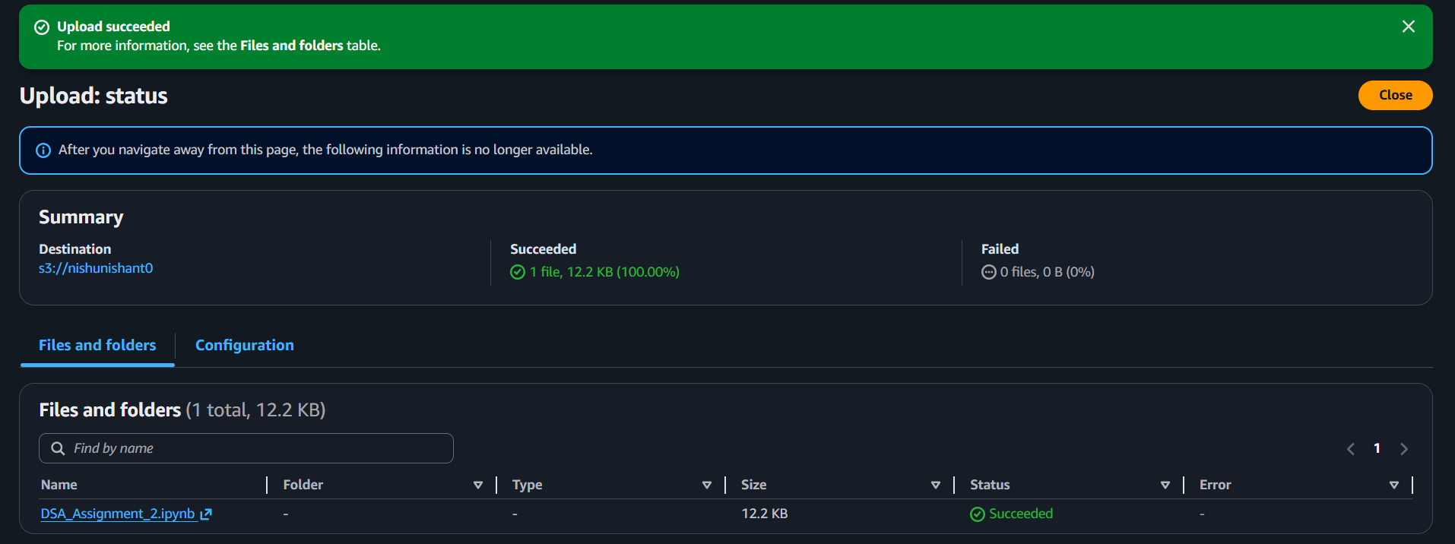
Object’s Dashboard
In the haadicoco bucket in Amazon S3, click on the uploaded file to open its object dashboard, where you can view details and manage the file.
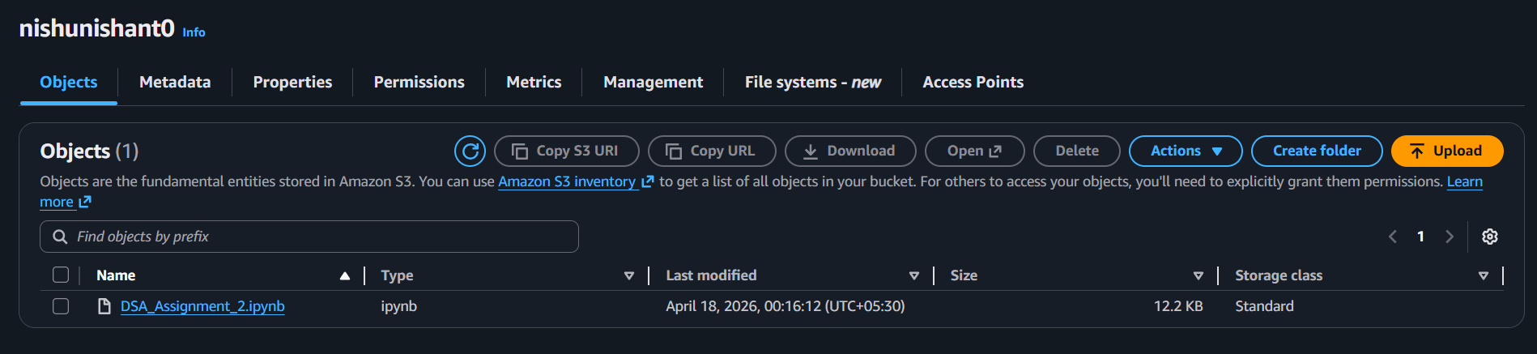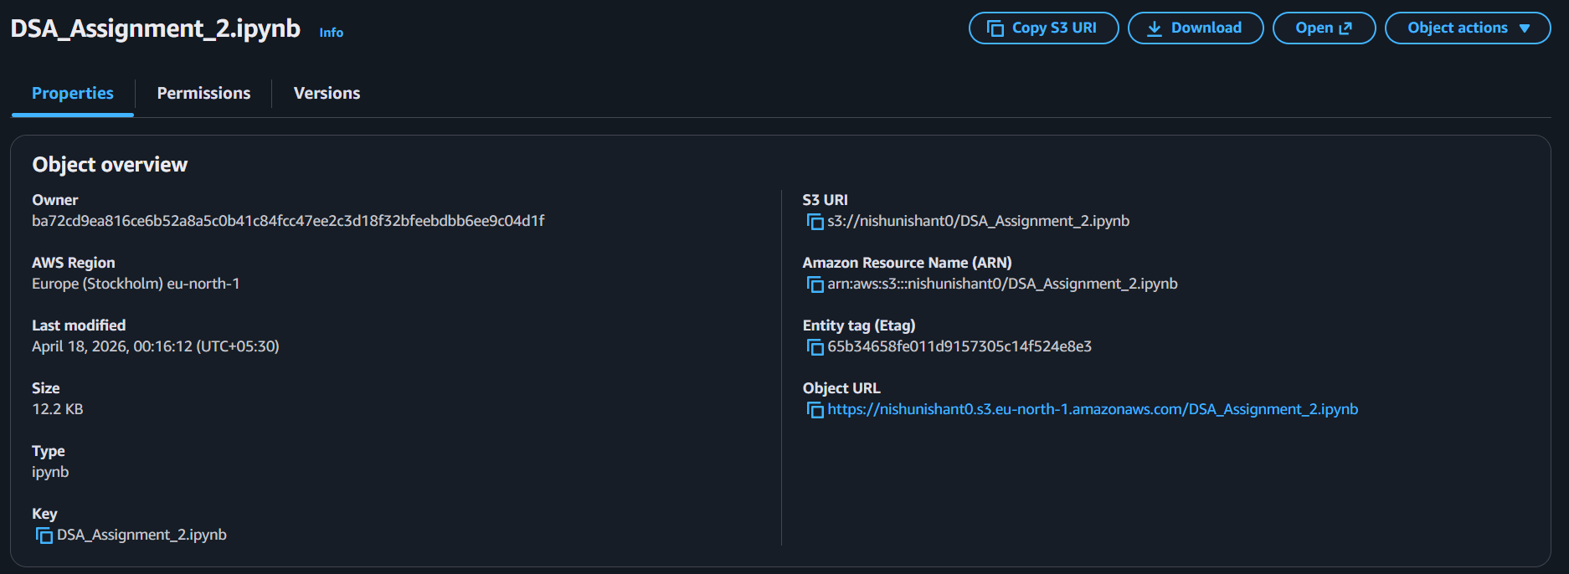
Making the Object Public
In the object dashboard of your file in Amazon S3, go to “Permissions” and make the object public to allow access to anyone via its link.
